**SHAMIR BLUE ZERO™**

This is a lens that is embedded with **blue-light protection** that suits the current digital lifestzyle. This technology can be used with a range of Shamir lens designs, such as Shamir Autograph Intelligence™ progressive lens, Shamir occupational lens, Shamir curve lens, etc.

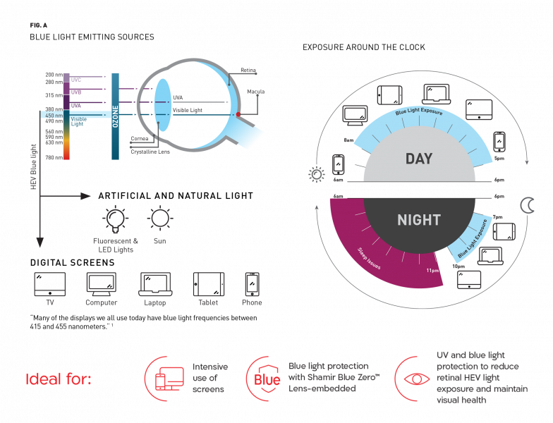

**SHAMIR AUTOGRAPH INTELLIGENCE™**

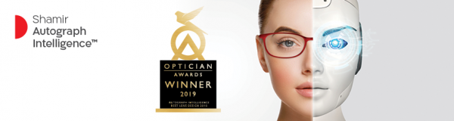

Harnessing today’s cutting-edge technologies, Big Data, and **Artificial Intelligence**, this is Shamir’s most advanced progressive lens that has a continuous lens design that optimally matches the wearer’s visual needs and **Visual Age™**. It won the **Lens Product of the Year’ Award** at the 2019 Optician Awards in Birmingham, United Kingdom.

**SHAMIR ATTITUDE SERIES**

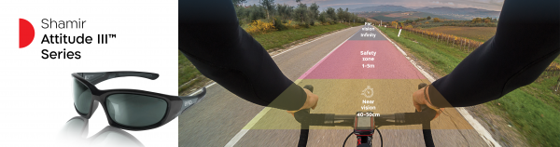

This is a **curve lens collection** that not only cater to single vision wearers, but also the **progressive wearer** with **ultimate vision comfort. Shamir Attitude III SV™,** is the single vision personalized curve lens designed specifically for sport and fashion frames; while the **Shamir Attitude III Sport™** and **Shamir Attitude III Fashion™** are progressive curve lens designed for active and trendy lifestyles.

**Book your appointment thru W OPTICS App to find out more about Shamir Optical Lenses!**

Consider this – between smartphones, computers, tablets, TVs, and other devices, many people spend an average of 8 to 10 hours a day looking at digital screens¹ or any near task. Prolonged screen time can cause digital eye strain, even after only two hours.² Switching between devices can make matters worse, as the eyes never have the chance to relax.

**Introducing Hoya accommodative support lenses, Sync III, specifically designed to help relax your eyes in a digital world.**

According to the study, the severity of eye strain symptoms reduced in 84% of the cases after wearing Hoya accommodative support lenses with 94.7% of wearers said to be satisfied with Hoya accommodative support lenses.³

Hoya Sync III executive single vision lenses have the distance power for everyday use and a ‘boost zone’ at the bottom of the lens, optimised for the way patients use their eyes today. The boost zone slightly increases lens power to support and relax the eye muscles so the eyes can focus more easily, relieving eye strain and enhancing visual comfort during up-close activities in a digital world.

Sync III lenses come in 3 boost zone options to address the varying degrees of digital eye strain symptoms: minimal, moderate, and severe.

Answer a simple questionnaire *(hyperlink:*[*https://sync.hoyaiselect.com/questionnaire*](https://sync.hoyaiselect.com/questionnaire)*)*to find out your digital profile and eye stress level!

Sync III lenses are suitable for:

1. Single vision wearers
2. Age 13-45
3. Wearers who spend two or more hours a day looking at digital screens or any near task
4. Wearers who experience digital eye strain symptoms

REFERENCES

1. Hoya data in file. Qualitative Research “Digital device usage”. The Netherlands and the USA, 2017.

2. Ang C., Dinevski D., Vlasak N., Kok A. Taking the strain. Optician. 05/2017, vol. 253, no. 6600, p. 25-28.

3. Gosling T. Helping relieve new visual demands. Optician. 06/2017, vol.253. no.6605, p.23-24.

Due to the global pandemic, keeping ourselves and our loved ones safe has become a priority.

**Personal health**, **protection** and **hygiene** became a necessity as we fear exposure to an invisible risk that could harm us and the people we care for.

We wear masks, sanitise our hands, and practise safe distancing – but are ‘high-touch items’ such as our spectacles protected from viruses and bacteria as well?

**ZEISS DuraVision AntiVirus Platinum UV coating** can potentially kill 99.9% of viruses and bacteria1 on the surface of your lenses.

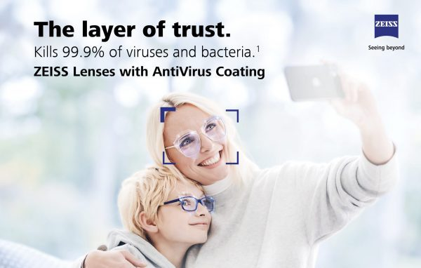

Get yourself and your loved ones protected today.

Sources:

1. Tested by ISO 21702:2019(E) for enveloped viruses;  
   Tested by ISO 22196:2011(E) for Gram-negative and Gram- positive bacteria.
2. Anti-viral efficacy proven by SMP Prüfen Validieren Forschen GmbH; Guang Zhou Institute of Microbiology;  
   GAPLAB Environmental Microbiology. Anti-bacterial efficacy proven by Guang Dong Detection Center of Microbiology; Sino-French Hoffman Institute.
3. Boone & Gerba (2007). Significance of fomites in the spread of respiratory and enteric viral disease. Applied and Environmental Microbiology, 73(6): 1687-1696.
4. Thompson & Bennett (2017). Persistence of influenza on surfaces. J Hosp Infect, 95:194–9.

Chances are you’ve probably noticed some difficulties when looking at your phone, or when looking at things up close.

You might have started to increase the font size on your mobile screens, or move it further away to see clearly.

You’ve probably started wearing reading glasses, and may need more vision support.

ZEISS SmartLife lenses are powered by **ZEISS SmartView Technology**, which is based on applied research of today’s lifestyle, visual behaviour, and individual, age-related needs. This allows ZEISS SmartLife lenses to be designed for:



If you are looking for more comfortable vision no matter near or far, **ZEISS SmartLife Progressive Lenses** could address your vision needs!

Sources:

1. External consumer acceptance test. Aston University, UK, 2019.